Price2Spy REST API - Postman Quick Start Guide

This guide explains how to import and use the official Price2Spy Postman collection for testing and integrating with the Price2Spy REST API using HMAC authentication.

1. Import the Postman Collection
1. Open Postman
2. Click the "Import" button
3. Select the exported Price2Spy collection JSON file
4. Confirm the import
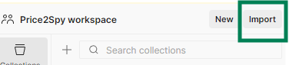
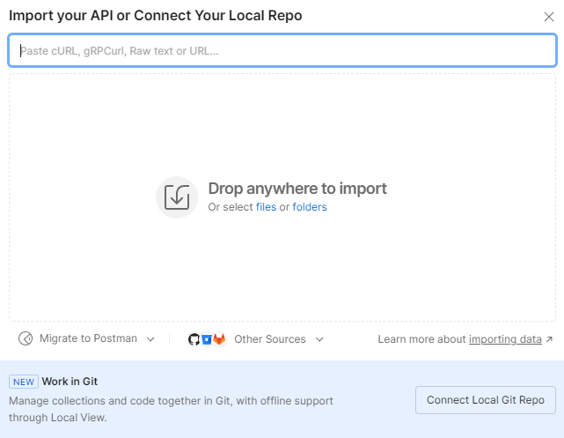

2. Configure API Credentials
1. Click the collection name
2. Open the "Variables" tab
3. Enter the following values (available in your Price2Spy account):
- client_id
- client_secret

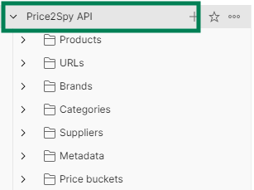

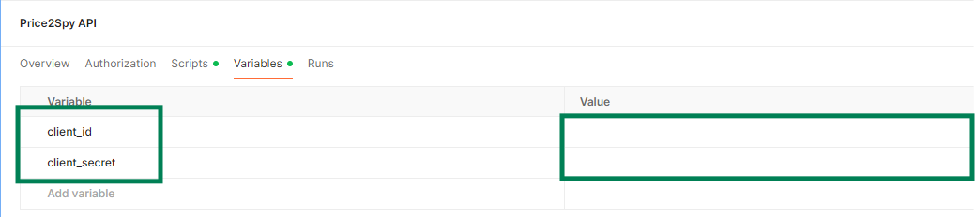

3. Send Your First Request
1. Open any request example from the collection
2. Review or modify the request body if needed
3. Click "Send"
4. Review the API response

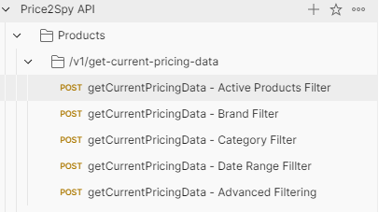

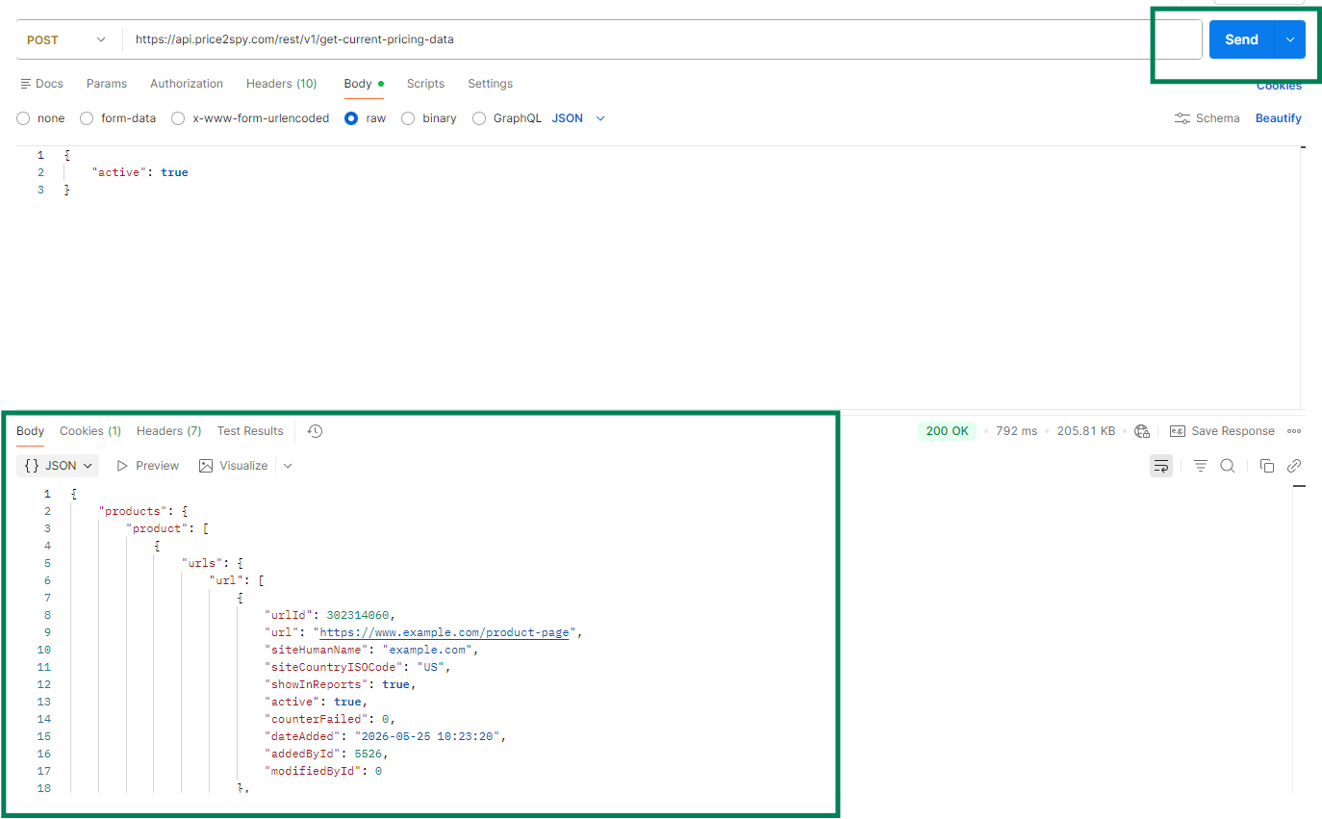

4. Using Request Documentation
Each folder and request in the collection contains additional documentation, request examples, supported filters, and usage notes.
To view documentation:
1. Click a collection, folder or request
2. Review the Description section

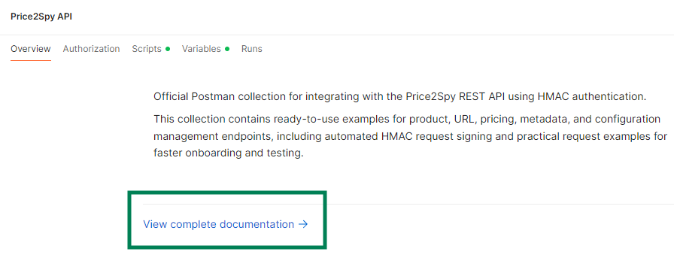

5. Request Examples
The collection contains ready-to-use examples for:
- Product filtering
- Brand filtering
- Category filtering
- Pricing data
- URL measurements
- Advanced filtering

6. Troubleshooting
If requests fail:
- Verify client_id and client_secret values
- Ensure the request body is valid JSON
- Verify that your API credentials are active
- Contact Price2Spy support if needed

Note:
Example values used in request bodies (brands, categories, suppliers, SKUs, metadata, etc.) should be replaced with values from your own Price2Spy account.

